**Arnold Schoenberg** was an Austro‑Hungarian composer, born in Vienna on 13 Sept 1874, who died in Los Angeles, 13 July 1951. He contributed to the genres of opera, choral music, orchestral music, chamber, piano, song, and made numerous arrangements. Originally a composer of opulent late Romantic music, in 1907‑8 Schoenberg began to compose atonal music in extreme expressionist style. Schoenberg had formulated the technique of twelve‑tone composition by the early 1920s, and was followed in this by many leading Western art music composers of the twentieth century, including his ‘Second Viennese School’ students Alban Berg and Anton Webern, and the transcendent Igor Stravinsky in all his late works, 1952‑66. In the twenty‑first century some composers still adopt a Schoenbergian, permutational approach to organizing melody and harmony. Schoenberg was forced by Nazi ideology to emigrate to the USA, and from 1936 taught at the University of Southern California in Los Angeles. He was one of the century’s foremost music theorists, from his *Theory of Harmony* (1911) to the posthumous pedagogical books which have remained in use to this day. His paintings, mostly dating from his mid 30s, were admired by Wassily Kandinsky and are still exhibited internationally.

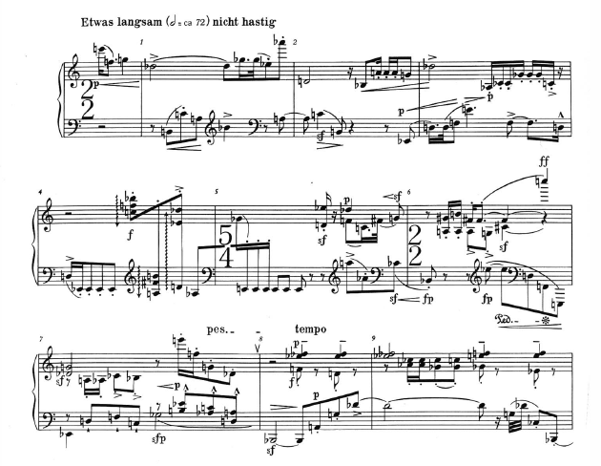

**Schoenberg, ‘Gavotte’, Op. 25, No. 2, opening: although the precise chronology is debated, this piece is probably the first acknowledged twelve‑tone composition, from 1923.**

[Public domain except USA: ©Belmont Music Publishers]

Schoenberg transformed musical composition in the early twentieth century, initially with a profound breakthrough in 1907‑8, analogous to Pablo Picasso’s development of cubism. Schoenberg himself found the term ‘atonality’ to be illogical, but he recognized that a new musical language had emerged, free from traditional major and minor keys and functional harmonic relationships. Over the next decade he experimented with pitch organization and in 1920-3 completed his first serial compositions. Early serial pieces or movements were based on a twelve‑tone row containing the chromatic pitches in a particular order selected from the millions of possibilities. A single row, often stated initially as a theme, in various combinations and permutations could provide the basis for a piece of music akin to the sense in which previously scales, chords and thematic motifs had formed the basis of tonal music, in complex ways that for centuries had been deeply understood only by professionals. Serialism of various kinds ultimately traceable to Schoenberg’s discoveries became a universally adopted compositional technique among the majority of modernist composers of Western art music, who were no longer content to recycle nineteenth‑century style. In his American years, the musical intensity of Schoenberg’s compositions was fascinating to Hollywood composers, so that many movie scores from the 1930s onwards adopted a distinctly Schoenbergian sound in places. Yet Schoenberg is also remembered for teaching that there is still plenty of good music to be written in C major.

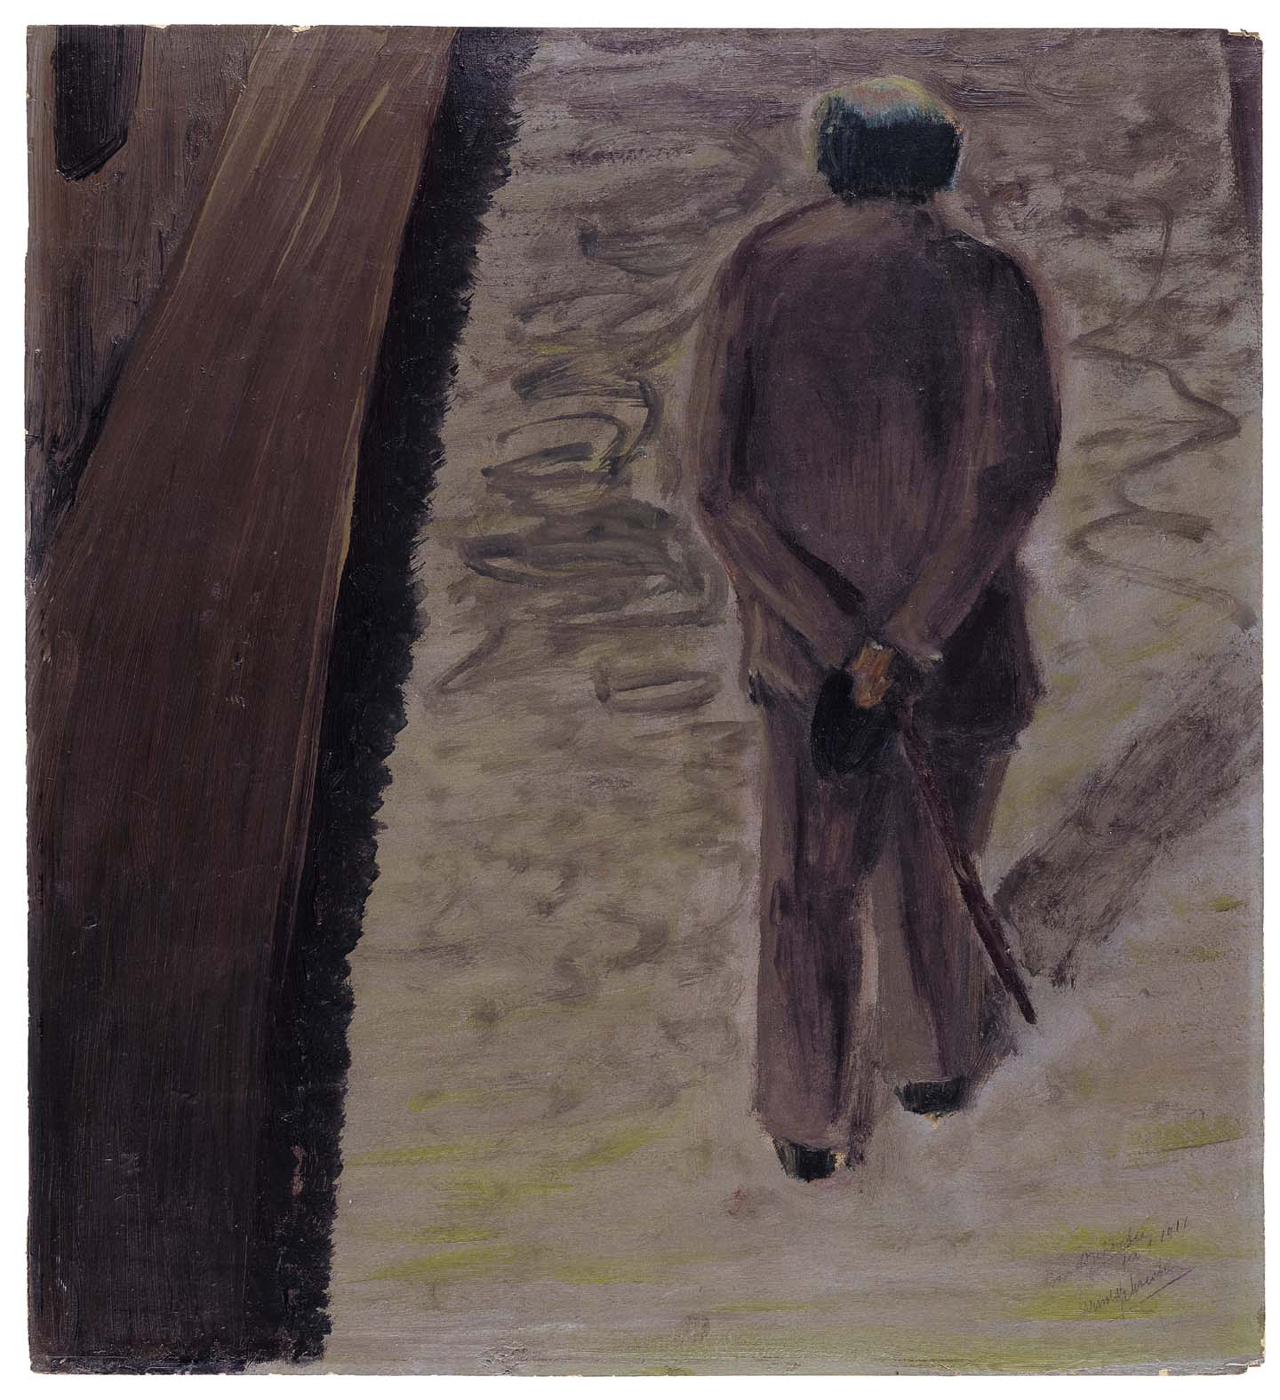

‘Walking Self-Portrait’

Oil on board

49 × 44,9 cm

signed and dated: Arnold Schoenberg /

fecit 1911 / Arnold Schoenberg

Owner: Belmont Music Publishers, Los Angeles

Located: Arnold Schönberg Center, Wien

**There are more than sixty self‑portraits by Arnold Schoenberg. This painting captures an image to perfection while reflecting the haunting atmosphere of expressionist art.**

[http://www.schoenberg.at/index.php?option=com_joomgallery&func=detail&id=25&Itemid=339&lang=en]

Schoenberg’s catalogue of completed compositions runs from the *Zwei Lieder*, Op. 1 (1898) to the *Moderner Psalm*, Op. 50c (1950). At an average of about one major work a year, his output was somewhat sporadic, interrupted by life events. Like others of his era born in Austria, he not only had to emigrate, but also experienced radical personal growth, for example renouncing his Jewish faith, as was fashionable in 1920s Europe, but re‑committing in Paris en route to America. He also had to endure decades of relentless, anti‑modernist press criticism. He recollected about the 1920s that ‘I had to express what was necessary to be expressed and I knew I had the duty of developing my ideas for the sake of progress in music…but I also had to realize that the great majority of the public did not like it’.

Even in his first period of composition Schoenberg was a pioneer. The work which put him on the musical map, *Verklärte Nacht* (Transfigured Night), completed on the last day of the nineteenth century, was a string sextet of symphonic proportions depicting a contemporaneous, modernist poem about young love. Less than a decade later, Schoenberg released his Second String Quartet, Op. 10, the third and fourth movements of which include soprano solo—a milestone in his habit of generic transformation. In the finale of Op. 10 the text tells of breathing ‘the air of other planets’ in a movement with not only no key signature but now no discernible key. In *Pierrot Lunaire*, Op. 21, a cycle of twenty‑one melodramas using theatrical, semi‑pitched declamation called ‘*Sprechstimme*’, the soprano is accompanied by a versatile ensemble (piano, violin/viola, flute/piccolo, clarinet/bass clarinet, cello), the ‘pierrot ensemble’ which became a core configuration for hundreds of works by composers worldwide in the ensuing century. Among Schoenberg’s serial works are the opera *Moses and Aron*, begun in 1930, and concertos for violin, Op.36, and for piano, Op. 42, both of which remain staples of the concert hall.

Schoenberg’s literary output was small but significant. His several hundred paintings, which continue to be exhibited around the world, were praised for their freedom and depth. He was noted particularly for expressionist portraits including self‑portraits, and a number of books have appeared over the decades about Schoenberg as artist. Schoenberg’s non‑musical creativity, including literary drama, is associated mostly with the years immediately following a personal tragedy in 1908 when his close friend, the painter Richard Gerstl, became his first wife’s lover and committed suicide when she returned to her husband. Throughout his life Schoenberg was an authoritative writer about music, whose essays eventually collected in *Style and Idea* (1975) are cited throughout the literature on Western art music, especially concerning the aesthetics of modernism. As a theorist, Schoenberg’s thinking dominated much of the twentieth century through his *Theory of Harmony* (1911). Also widely disseminated were his later music theory pedagogy books based on his American teaching in his 60s and 70s, especially *Fundamentals of Musical Comp*osition and *Structural Functions of Harmony*, both published posthumously.

Schoenberg’s legacy has been promoted and his archives preserved by the Arnold Schönberg Center since 1998 in his native city of Vienna: [www.schoenberg.at](http://www.schoenberg.at)

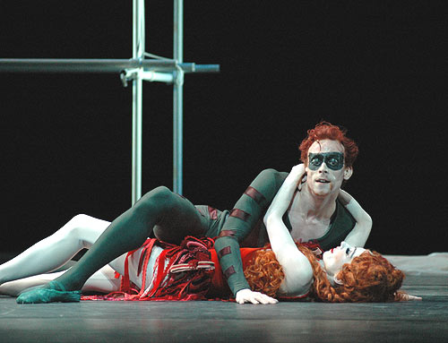

***Pierrot Lunaire* has been popular as a ballet score: an image from a Royal Ballet (UK) production, 2007, nearly a century after the work’s premiere in the original concert version, Berlin, 16 October 1912.**

**©John Ross**

[http://www.ballet.co.uk/gallery/jr_rb_deadlysins_pierrot_findujour_0407/jr_pierrot_watson_galeazzi_floor_500]

**LIST OF WORKS**

The majority of Schoenberg’s compositions are regular items in the classical music repertoire. The following list, with dates of completion, represents the scope of his imagination and compositional technique.

Opus

4: Transfigured Night (*Verklärte Nacht*), 1899, string sextet. Schoenberg’s first famous composition, considered overly modernistic by the Viennese musical establishment, subsequently regarded as a classic of what is often called music in transition—from Romanticism to modernism.

9: First Chamber Symphony, 1906. On the cusp of atonality, and a herald of the smaller‑force genres of early modernism.

10: Second String Quartet, 1908, for string quartet and soprano (movements 3 and 4), texts by Stefan George. The first concpisuous fusion piece that brought song into chamber music.

16: Five Orchestral Pieces, 1909. A major work for the symphony hall, introducing *Klangfarbenmelodie* (tone‑color melody, where changing sounds rather than pitches form the main melodic interest) in No. 3.

17: *Erwartung*, 1909, monodrama for voice and orchestra, text by Marie Pappenheim. Extreme expressionism, with a text based on anguished states of mind rather than plot, and a musical score with such a degree of non‑repetition as to make its melody and harmony seem essentially random.

19: Six Little Piano Pieces, 1911. Some of the most frequently theorized music in the twentieth century, ‘atonal’ but redolent of late Brahms in its piano style. No. 6 was said to represent the sound of the bells at Gustav Mahler’s funeral in Vienna, something which for forty years Schoenberg never denied. Nos 2 and 6 are well within the capacity of amateur pianists.

21: *Pierrot lunaire*, 1912, 21 melodramas for voice and chamber group, text by Albert Giraud. This guaranteed Schoenberg’s fame and established a new core ensemble and new vocal technique.

26: Wind Quintet, 1923. One of the first large‑scale twelve‑tone compositions.

31: Variations for Orchestra, 1926. One of earliest twelve‑tone works to find a permanent place in the symphony hall.

41: ‘Ode to Napoleon’, 1942, for reciter and piano quintet, text by Bryon. Byron’s commentary on Napoleon’s tyranny became here an unmistakable protest at the contemporaneous Hitler regime and the ravages of the Second World War. Schoenberg adapts twelve‑tone technique to integrate clearly audible references to Beethoven’s Fifth Symphony.

45: String Trio, 1946. Schoenberg said that he had depicted his nearly fatal heart attack in this final masterpiece of serial chamber music.

**REFERENCES AND FURTHER READING**

Bojan Bujić, *Arnold Schoenberg*, London, 2011. The most up‑to‑date study of Schoenberg’s life and works, accessible but providing critical insight into complex musicological and cultural issues.

Jennifer Shaw and Joseph Auner, *The Cambridge Companion to Schoenberg*, Cambridge, 2010. Representing current scholarship but in readily digestible form.

Walter Frisch, ed., *Schoenberg and His World*, 1999. Provides varied critical perspectives and documentation in light of Schoenberg scholarship which had become probing in the decades since his death, as a result of wide theoretical discussions and much musicological research on his extensive archive, originally housed in Los Angeles. Includes essays on Schoenberg as pedagogue and painter.

Julie Brand and Christopher Hailey, eds, *Constructive Dissonance: Arnold Schoenberg and the Transformations of 20th-Century Culture*, 1997. Output of a major symposium in Los Angeles on Schoenberg’s central role in twentieth‑century modernism.

Haimo, Ethan, *Schoenberg’s Serial Odyssey: the Evolution of his Twelve-Tone Method, 1914–1928*, 1990. The first authoritative account of how twelve‑tone composition emerged in Schoenberg’s 30s and 40s.

Arnold Schoenberg, *Style and Idea*, New York, 1975. A compendium of Schoenberg’s essays and lectures on the theory, history and aesthetics of Western art music, including considerable focus on the issues of modernism in musical composition.

Charles Rosen, *Arnold Schoenberg*, 1975. A milestone in the assimilation of Schoenberg’s creative path by one of the leading musical commentators partly of his era, this provides a lucid and penetrating critical overview of all Schoenberg’s compositions.

Jonathan Dunsby